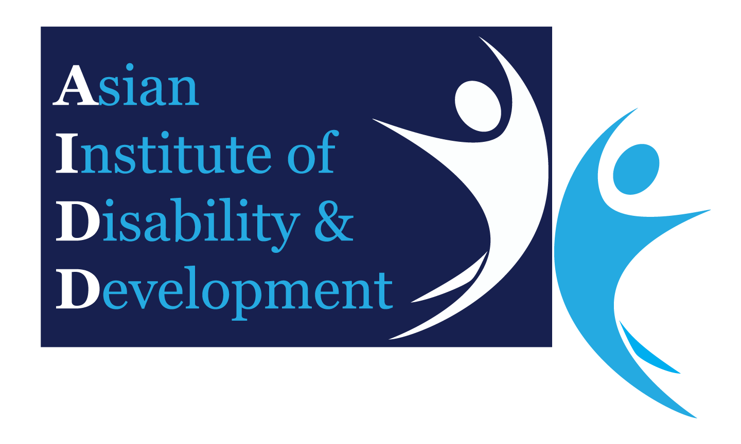Research Approval Application

To Asian Institute of Disability and Development (AIDD) Research Committee

***(Electronic Format Only)***

Submit to: ***disabilityasia@gmail.com***

|  |  |
| --- | --- |
| Date: | DD / MM / YYYY |

|  |  |  |  |  |
| --- | --- | --- | --- | --- |
| **Project Title:** | Assessment of quality of antenatal care provided to pregnant women receiving health care in union level health and family welfare centers in the selected union of Golapganj Upazila in Sylhet district. | | | |
| **Names(s), Titles(s), Qualifications, Dept/Locations and Contact Details** | | | | |
| **Principal Investigator:** | | Khaleda Habib, Student ID# 191-0022-011, Mobile# 01741597899, e-mail address: [khaleda2010_habib@yahoo.com](mailto:khaleda2010_habib@yahoo.com) | | |
| **Associates and Co-Investigator:** | |  | | |
| **Proposed Date of project commencement:** | | | January 2020 | |
| **Proposed Duration of Project:** | | | April 2020 | |
| **Summary of Project:**  *(Including impact on pregnant women in across the world and Bangladesh)* | | There are wide disparities in antenatal care across countries [1, 2]. The lowest levels of antenatal care are observed in sub-Saharan Africa and South Asia. The World Health Organization (WHO) recommends a minimum of eight antenatal care contacts to reduce perinatal mortality and improve women’s experience of care. However, global, regional and comparable country reported data are only available for the previous recommendation which was a minimum of four visits. Currently available data indicate that women receive at least 4 antenatal care visits. Globally, while 86 per cent of pregnant women access antenatal care with skilled health personnel at least once, only two in three (65 per cent) receive at least four antenatal visits. In regions with the highest rates of maternal mortality, such as sub-Saharan Africa and South Asia, even fewer women received at least four antenatal visits (52 per cent and 49 per cent, respectively). In viewing the data, it is important to remember that these percentages bear no reflection on either the skill level of the health-care provider or the quality of care, both of which can influence whether such care actually succeeds in bringing about improved maternal and newborn health. The 1999-2000 DHS indicates that many mothers in Bangladesh do not receive antenatal care [3]. For births that occurred in the five years before the survey, nearly two-thirds (63%) of mothers received no antenatal care (ANC) during pregnancy. Those who do receive care tend to receive it from doctors (24%), or nurses, midwifes or family planning visitors (10%).Among the women who do obtain care, the median number of antenatal visits is only 1.8, far less than the WHO recommended minimum 4 visits. ANC visits are much more common for younger women and for those of lower birth parity. There are also regional variations in use of antenatal services, as 59% of urban births had received antenatal care compared to only 28% in rural areas. Difference in antenatal coverage by division is minimal. Mothers in Sylhet division are least likely to receive antenatal care, for only 27% of births the mothers in this division have at least one antenatal care visit. For decades, Sylhet division has lagged behind other regions in health indicators, and over time this trend has not changed significantly. Bangladesh Maternal Mortality and Health Survey (BMMHS) 2010 estimates that two causes, eclampsia (hypertensive disorders) and hemorrhage (bleeding, particularly after delivery), contribute to about half the maternal deaths as Antenatal Care (ANC) utilization is low and home births are the norm, both issues require community based identification and management by service providers. The major contributors to the lower rates of key health indicators in different facilities in Sylhet are HR vacancies/absenteeism in UH&FWCs, inadequate outreach activities, lack of ANC logistics and essential medicines, high treatment costs, low community awareness and minimum local government participation in health seeking behavior of maternal health activities.  This study has aimed to show that ANC visits is an effective way for preventive measures for a pregnant woman and it also needs to be monitored that quality has ensured through this care. According to WHO, the standard quality of ANC is comprised of three components: (i) assessment, that is history taking, physical examination and laboratory tests, (ii) health promotion, that includes advice on nutrition, planning the birth, information regarding pregnancy, subsequent contraception and breastfeeding, and (iii) care provision that is comprised of tetanus toxoid immunization, psychosocial support and recordkeeping [[2](https://www.ncbi.nlm.nih.gov/pmc/articles/PMC6160162/#pone.0204752.ref002)]. Although there may be variations in the national strategies about the content of ANC, WHO recommends a core set of services which include blood pressure measurement, tetanus toxoid vaccination, urine testing, iron tablet supplementation, body weight measurement and counseling about danger signs. Yet, in most of the developing countries, a large proportion of women do not receive the minimum four visits [[10](https://www.ncbi.nlm.nih.gov/pmc/articles/PMC6160162/#pone.0204752.ref010)] and the compliance to minimum level of recommended content for ANC appeared to be unmet due to poor accessibility, inability to afford the costs of seeking care, cultural barriers and lack of knowledge. Bangladesh, a South-East Asian developing country, is not an exception. The Ministry of Health and Family Welfare (MH&FW) Bangladesh follow the WHO recommended ANC visits and the core contents of ANC visits. | | |
| **Aims & Significance**  *(Include Research Question/s and Hypothesis)* | | Research questions: How to assess that quality of antenatal care has ensured among the pregnant women receiving health care from those health facilities in the Union of Sylhet district.  Hypothesis: The objectives of this study are to describe the coverage and content of ANC contacts in the context of rural hard to reach union level health facilities in Sylhet. This study will bring an opportunity to strengthen the health systems in union level health facilities of Sylhet through assess the different contents of quality antenatal care among the key beneficiaries (pregnant women) are receiving health services during pregnancy i.e. basic indicators of ANC (Weight taken, BP measure, Urine sample collection, Blood sample collection & Inform about danger signs) and cordial behavior from providers including proper counseling etc. | | |
| **Justification**  *(including literature review and background)* | | Antenatal care (ANC) has long been considered a critical component of the continuum of care for women during pregnancy, with the potential to contribute to the survival and thriving of women and newborns [4]. This essential service allows women to be screened during their pregnancies for pre-existing conditions and potential complications, allows for initiation of timely and appropriate treatment, and provides a platform for women to receive counselling, which can support them to protect their health and that of their baby throughout the antenatal, birth and postnatal periods. Moreover, ANC is becoming increasingly important as a service as the world undergoes an obstetric transition. In this transition, preventable maternal mortality is becoming predominantly the result of indirect causes and non-communicable diseases, which requires more individualized care. ANC can provide an optimal platform for catering the individual care by screening and timely management. Promisingly, utilization of ANC has been increasing steadily throughout the past decades, with 86% women worldwide now attending at least one ANC contact and 62% receiving at least four ANC contacts between conception and birth. However, even as ANC utilization has increased over the past two decades, the content and quality of this care have fallen under increased scrutiny, as poor quality compromises the potential benefits of care. With the new targets set out in the Sustainable Development Goals (SDGs) aiming to reduce maternal and newborn deaths to unprecedented levels, and the ambitious ‘Survive, Thrive, Transform’ agenda of the Global Strategy for Women’s, Children’s and Adolescent’s Health, ensuring the quality of maternal and newborn health (MNH) services, including ANC, is as important as ever.  The World Health Organization (WHO) recently updated its ANC guidelines based on the global evidence base [2]. The new guidelines are notable in their adoption of a human rights-based approach and a focus on people-centred care. This emphasizes not only clinical service provision but also the experience of care; so that adolescent girls and women are able to benefit from a positive pregnancy experience. Moreover, it is now recommended that each woman attend eight of more routine ANC contacts between conception and birth, rather than the four or more suggested by the previous model [2]. The new guidelines are more expansive and comprehensive than the previous model, and clearly have the potential to improve the pregnancy experience and outcomes. During the Millennium Development Goals-era, the global coverage of ANC contacts inched forward, but many countries struggled to ensure adherence to the recommendations contained in the previous model. Based on this experience, it will be challenging for the countries with limited resources to ensure the adherence to the more comprehensive recommendations. A number of studies have explored the degree to which the recommended content of ANC contacts are adhered to in different countries. In general, these studies demonstrate the poor status and existing gaps related to the content of ANC contacts, even in the context of high-resource settings, much less in low and middle-income countries (LMICs).  Bangladesh has made impressive gains in reducing maternal and neonatal mortality over the past several decades, but total number and rates of these deaths remain too high. Moreover, the latest Bangladesh Maternal Mortality Survey suggests that progress in reducing maternal mortality has stalled. Use of key MNH services remains critically low. Indeed, only 37% pregnant women attend at least four ANC contacts, 47% of births occur in health facilities and 48% (6% in the case of home-based births) of women receive postnatal care from a skilled health-care professional within the first two days after birth. While the BMMS-2016 revealed that use of skilled health services during pregnancy has increased over the past decade, this has not translated into an expected reduction in maternal mortality between 2010 and 2016. This suggests that focusing solely on increasing coverage of these services is not sufficient to translate into improved health. The content and the quality of these contacts must also be ensured [2] | | |
| **Statement of Outcomes & Benefits** | | This study may supportive for the policy makers to illustrate the situation of union level health facilities in Sylhet on how these are running antenatal care following the national guideline and maintaining the quality during each visits with all essentials service package towards the pregnant women. Moreover, this study also intends to improve the Govt. rural health systems there in Sylhet to increase the ANC coverage. | | |
| **Method** | | | | |
| **Design** | | Cross-sectional | | |
| **Participant Inclusion/ Exclusion Criteria** | | Pregnant women of study areas will be participated willingly during the study period. | | |
| **Recruitment** | | Convenience sampling tools will be used for this study. | | |
| **Dissemination of Results & Recommendation** | | Study finding will be depicted both tabular form and graphical chart. | | |
| **Allocation of Resources (AIDD Staff Only)** | | | | |
| **Staff Time** | |  | | |
| **Other – give details** | |  | | |
| This research proposal may be submitted to an external reviewer with appropriate expertise in the topic.  Please indicate if you have any objection to this process. | | | | |
| * I do not want this proposal submitted for external review: | | | | □ Yes □ No |
| * I do not want this proposal reviewed by the following person(s): | | | |  |

**References:**

1. <https://data.unicef.org/topic/maternal-health/antenatal-care/>
2. World Health Organization, 2016, [WHO recommendations on antenatal care for a positive pregnancy experience 2016](https://www.who.int/reproductivehealth/publications/maternal_perinatal_health/anc-positive-pregnancy-experience/en/)
3. <https://assets.publishing.service.gov.uk/media/57a08cf4ed915d622c0016a7/02-03_bangladesh.pdf>
4. <https://journals.plos.org/plosone/article?id=10.1371/journal.pone.0205149>